A

PROJECT REPORT ON

# “Online Job Portal”

SUBMITTED IN PARTIAL FULFILLMENT OF

DIPLOMA IN ADVANCED COMPUTING (PG-DAC)

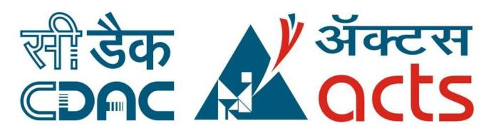

**UNDER THE GUIDANCE OF:**

## Ms. Nargis P.

***PRESENTED BY:***

220340120200: Sourabh M Patil.

220340120027: Ashish S Patil.

220340120033: Aman T Attar.

220340120038: Tejas S Bavkar.

220340120135: Omkar Gaikwad.

**AT**

**CENTER FOR DEVELOPMENT OF ADVANCED COMPUTING**

**C-DAC, PUNE**

# ACKNOWLEDGEMENT

The project “Online Job Portal” was a great learning experience for us and we are submitting this work to Advanced Computing Training School (C-DAC ACTS, Pune).

We are very glad to mention the name of Ms. Nargis P for her valuable guidance to work on this project.

We are highly grateful to Ms. Risha P. R., Manager of ACTS Training Centre, CDAC, for her guidance and support whenever necessary during the course of our journey to acquire PG-Diploma in Advanced Computing (PG-DAC) through CDAC ACTS, Pune.

Our heartfelt thanks go to Ms. Shilpi Shalini (Course Coordinator, PG_DAC) who gave us all the required support and kind coordination to provide all the necessities to complete the project and throughout the course up to the last day of the course.

We would like to express our sincere gratitude towards Mrs. Madhura Anturkar, our faculty for J2SE and J2EE, who was always there for us. Her guidance and support helped us overcome various obstacles and intricacies during the course of our project work. Without her tremendous support, guidance, and efforts, this project would not have been possible.

From:

|  |  |
| --- | --- |
|  |  |
| Ashish Patil  Sourabh Patil  Aman Attar | 220340120027 220340120200  220340120033 |
| Tejas Bavkar | 220340120038 |
| Omkar Gaikwad | 220340120135 |

# TABLE OF CONTENTS

|  |  |
| --- | --- |
|  | ABSTRACT |
| 1. | INTRODUCTION |
| 2. | PRODUCT OVERVIEW AND SUMMARY |
|  | 2.1. Purpose  2.2. Scope  2.3. Overview  2.4. Feasibility Study |
| 3. | REQUIREMENTS FULFILLED |
|  | 3.1. Functional Requirements  3.2. Non-Functional Requirements |
| 4. | PROJECT DESIGN |
|  | 4.1. Data Model  4.2. Data Flow Diagram  4.3. Use Case Diagram  4.4 Sequence Diagram  4.5. Activity Diagram  4.6. Project Architecture  4.7. ER Diagram |
| 5. | PROJECT SCREENSHOTS |
|  | 5.1. Recruiter  5.2 Employee  5.3. Admin |
| 6. | TESTING |
| 7. | CONCLUSION |
| 8. | FUTURE SCOPE |
| 9. | REFERENCES |

# ABSTRACT

Job portal service was developed for creating an interactive job vacancy form for candidates. This web application manages updates both from the job seekers as well as the companies. It’s unique development methodology helps in acquiring the client and candidate information and separating them according to the job requirements.

The online access to it provides details of the job. An employer being registered in the web site has the facility to use the services. Being an authorized user he can publish vacancy details and can search no of Employees on portal and also he can search candidates on basis of the key skill which employee provides on registration.

# 1. INTRODUCTION

Now a day, we know that searching of jobs is so difficult in proficient areas the portal developed for the providing the simple and good job searching. With the help of this portal easily the job seeker can submit their resume and get the lot of opportunity of the job related to their profile. And by this website the companies or employer can also find the good and well profiled resume.

This system can be used as an Online Job Portal for the placements.

Many times we see that, there are recruiters who are not able to find right

candidate for their jobs; also there exists some capable candidates who are not getting great opportunities according to their skillset. So to overcome this unreachability we have choose to bridge in between recruiters and job seekers by "Online Portal" and there we got idea about developing a "Online Job Portal".

We need to go as local as possible to fulfill purpose of project and provide excellent and user friendly API for job seekers and recruiters.

# 2. PRODUCT OVERVIEW AND SUMMARY

2.1. PURPOSE

This system can be used as an Online Job Portal for the placements.

Many times we see that, there are recruiters who are not able to find right

candidate for their jobs; also there exists some capable candidates who are not getting great opportunities according to their skillset. So to overcome this unreachability we have choose to bridge in between recruiters and job seekers by "Online Portal" and there we got idea about developing a "Online Job Portal".

We need to go as local as possible to fulfill purpose of project and provide excellent and user friendly API for job seekers and recruiters.

## 2.2. SCOPE

As of Indian market, there is ample opportunities for the job portal sites, as more and more number of educated and skilled young people are coming out each and every year. Also, as the growth rate of India is zooming to be at a healthy rate over 7%, so it is boom time for corporate also. So, more and more number of lucrative careers will be available for the job seekers. So, it is now the right period for the job portal sites to think out of the box, and to make most of the opportunities available.

### 2.3. OVERVIEW A. TECHNOLOGIES USED

i. FRONT END

* HTML
* CSS
* JavaScript
* Bootstrap
* React
* Axios

1. BACK END
   * Spring Boot
   * Spring Data JPA
   * Hibernate
   * REST

1. DATABASE MANAGEMENT SYSTEM
   * MySQL

#### B. FEATURES PROVIDED

* FOR EMPLOYEE:
  + 1. Browse – Employee can browse the homepage to explore the entire functionalities for employee.
    2. Register, Login & Logout – New Employees can register on the site. Existing employees can then login to access their account information and logout when the account is not in use
    3. Search – Employee can search for the jobs they want on basis of job profile.
    4. Advanced Search by Experience – Employee can filter and search through jobs by advanced criteria like the job description and experience.
    5. View & Apply Job– When an employee checks job, they can also view the job in detail and they can apply for that job.
    6. View & Update Profile – When logged in, employees can view their profile and update their details.
    7. Delete Account – If the employee no longer wishes to be involved with the site, we give them freedom so that they can delete their account.
    8. Add Skills and Add experience – Apart from editing basic profile skills and experience are things keep changing for an employee so we made different section for adding them.
* FOR RECRUITERS

1. Browse – Recruiter can browse the homepage to explore the entire functionalities for Recruiter.
2. Register, Login & Logout – New Recruiter can register on the site. Existing Recruiter can then login to access their account information and logout when the account is not in use.
3. View posted job & Job Applicants–Recruiter can see the posted jobs and applicants for that particular jobs.
4. Search Employee: Search – Recruiter can search for the Employee they want on basis of job profile required skills.
5. Advanced Search by Experience – Recruiter can filter and search Employee by advanced criteria like the experience.
6. Add jobs- Recruiter can add more jobs if needed in future.
7. Calling candidate for interview- Recruiter can send email to employee for interview call directly from website.
8. Delete jobs- Recruiter can delete job if requirement is get fulfilled.

Delete Account – If the Recruiter no longer wishes to be involved with the site, we give them freedom so that they can delete their account.

* FOR ADMINS

* + 1. Login & Logout – Similar to employees and recruiters, admin can login & logout to access their account.
    2. Fetch recruiters - The admin can fetch all recruiters.
    3. Fetch Employees - The admin can fetch all Employees.
    4. Delete Employees and recruiters –The admins can delete employee and recruiter’s account if they need to for any purpose.

2.4. FEASIBILITY STUDY

Feasibility is the determination of whether a project is worth undertaking or not. Before actually recommending the new system, it is important to investigate if it is feasible to develop it.

Before developing and implementing a system, we have to make sure that the system is feasible in the following ways:

### A. TECHNICAL FEASIBILITY

In this type of feasibility study, the system analyst has to check whether it is possible or not to develop the requested system with the available manpower, software, hardware, etc.

This project makes use of cross-platform software and solutions like Java, and hence can run on any operating system. React, used in front-end, is swift and light weight framework when it comes to delivering the requested page as it doesn’t reload the entire page for every HTTP request. It only re-renders the components that need to fetch new data. Also, as React is modular in nature, it is easy to develop new components and scale up existing components in order to add new features to the system. The combination of Spring Boot, Spring Data JPA and Hibernate for backend make for a fast, easy to set-up and reliable system to interact with the database, as they are secure and transactional in nature. Since the sensitive data of customers and admins need to be stored in a robust and secure database, MySQL database management system was chosen as it is an industry standard.

### B. OPERATIONAL FEASIBILITY

In this type of feasibility study, the operation of the system is considered. An analysis is performed on whether it is feasible for the user department to use the application. Thus, the proposed system is said to be operationally feasible only if clients are able to understand the system clearly and correctly, and can use it with ease.

In the design of this project, we always kept user experience in mind. We made an effort to have a good user interface with consistent theme and alluring design to keep the users interested and engaged. In our project, the use of universally known icons and instructions that are easy to understand makes sure that the user will not need any special technical know-how to use the application. We made sure that the information available throughout the application is arranged in a logically coherent and consistent manner, guaranteeing that the users will have a smooth and effortless experience and even enjoy using the application.

#### C. ECONOMIC FEASIBILITY

In this type of feasibility study, the benefits of the system to the organization are considered by taking into consideration the cost-benefit analysis. All the software and technologies used in our project free, open-source, and widely available, with each of the technologies having an extensive community support. This makes “Online Job Portal” an economically feasible solution to the organizations that wish to implement it.

# 3. REQUIREMENTS FULFILLED

3.1. FUNCTIONAL REQUIREMENTS

Following are the functional requirements fulfilled by our project:

* Employees can browse through all available jobs and search them based on job profile or perform an advanced search by filtering using job description and experience.
* Employee can apply jobs for job.
* Based on their experience, employees can get required jobs.
* Employees can add skills and experience and edit their profile.
* Recruiters can add new jobs to their profile.
* Also they can view who are employees who have applied for specific job.
* Recruiters can also delete job.
* Both Employees and Recruiters can delete their account if wanted.
* Admins can delete users if the need arises.
* Also they can view all information about employees and recruiters.

3.2. NON-FUNCTIONAL REQUIREMENTS

Following are the non-functional requirements fulfilled by our project:

* Since the application uses lightweight and established software components that are also cross-platform, it is remarkably performant and has good support for every operating system.
* The use of React for front end and Spring Boot, Spring Data JPA and Hibernate for back end delivers quick response times to admins and customers alike.
* Card-style UI and well-known icons and symbols used throughout the application provides a consistent theme and user-friendly interface that anyone can grasp easily, even without a technical background.

# 4. PROJECT DESIGN

4.1. DATA MODEL

The following tables depict the database design used for “Online Job Portal” application:

## A. Tables Related to Employee Details

1. Employee Table

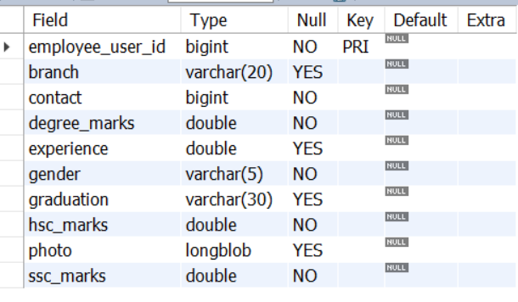

1. Skills Table

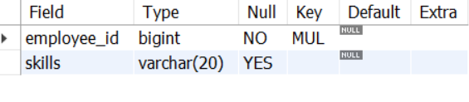

1. Employee Job Table

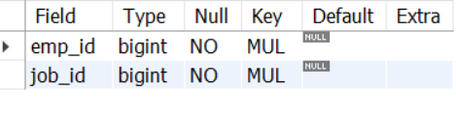

1. Tables Related to Recruiters
   * + 1. Recruiter Table

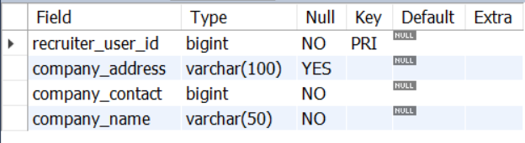

* + - 1. Job Table

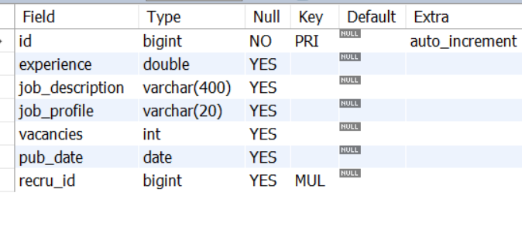

1. Tables Related to User
2. User Table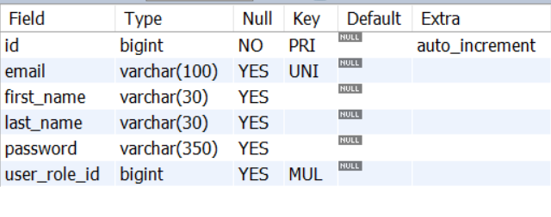
3. Role Table

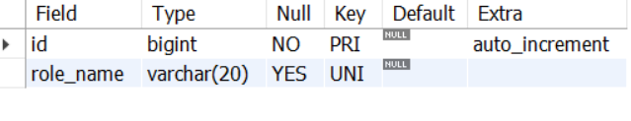

* 1. DATA FLOW DIAGRAM

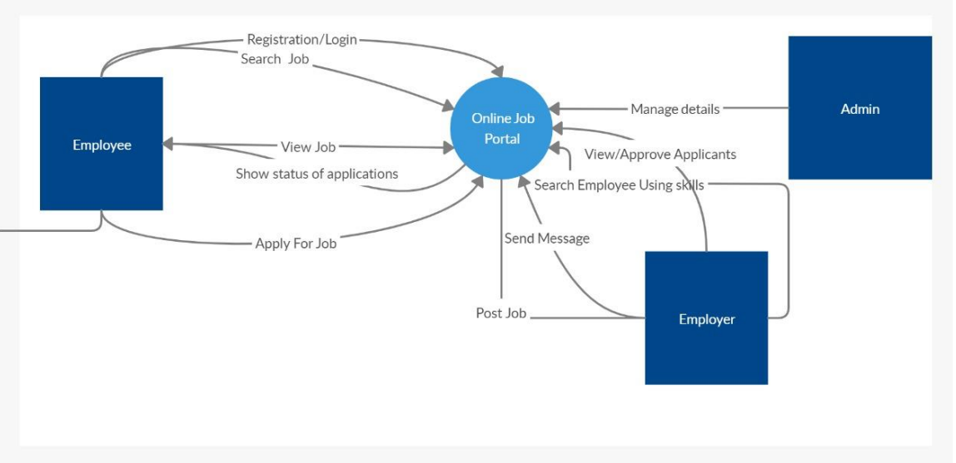

* 1. USE CASE DIAGRAM

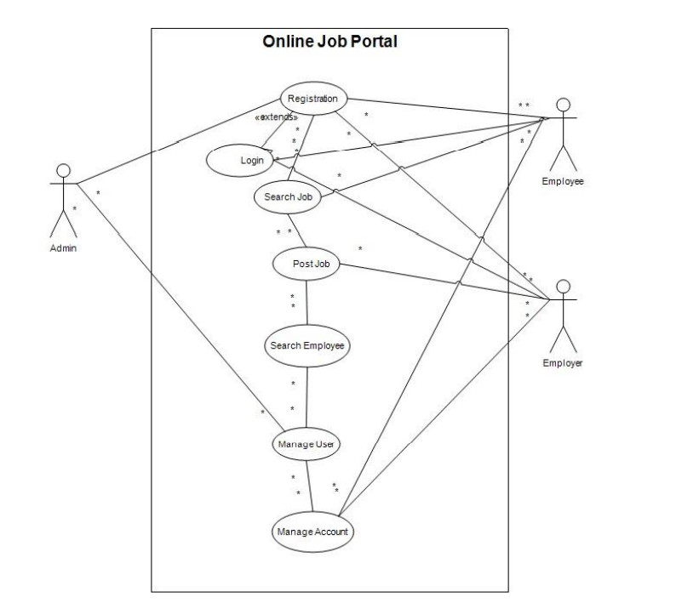

* 1. SEQUENCE DIAGRAM

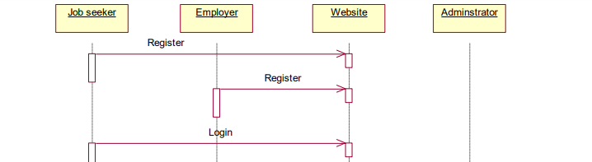

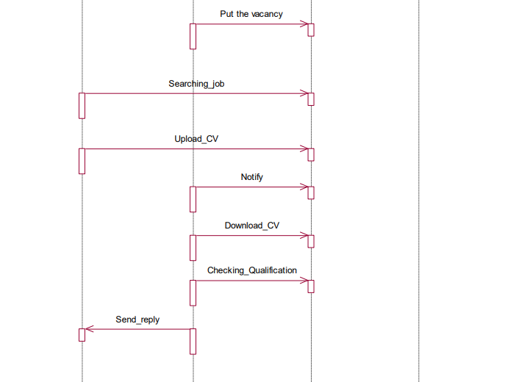

* 1. ACTIVITY DIAGRAM

1. EMPLOYEE ACTIVITY DIAGRAM

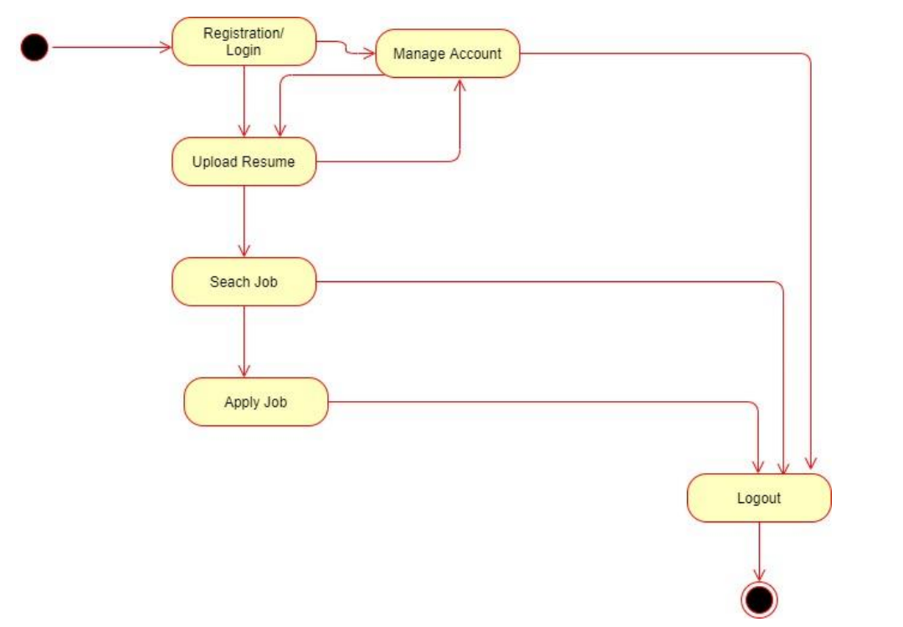

1. RECRUITER ACTIVITY DIAGRAM

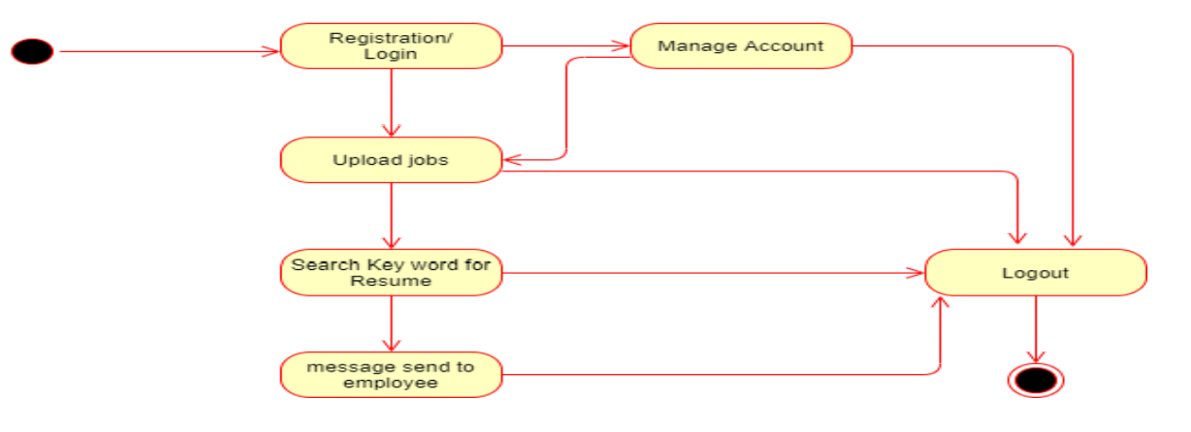

4.6. PROJECT ARCHITECTURE

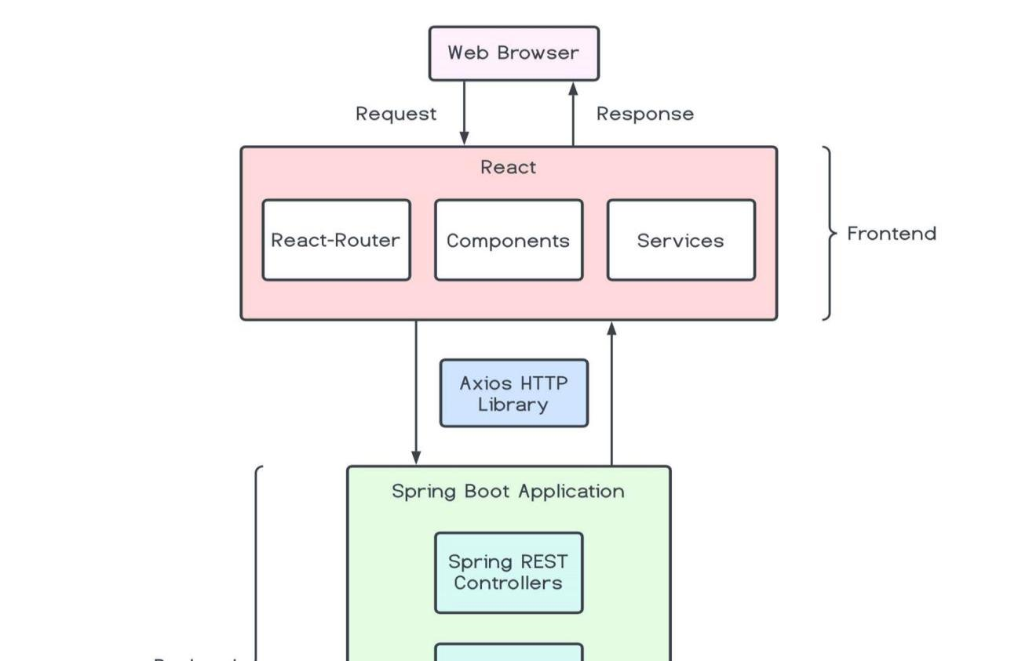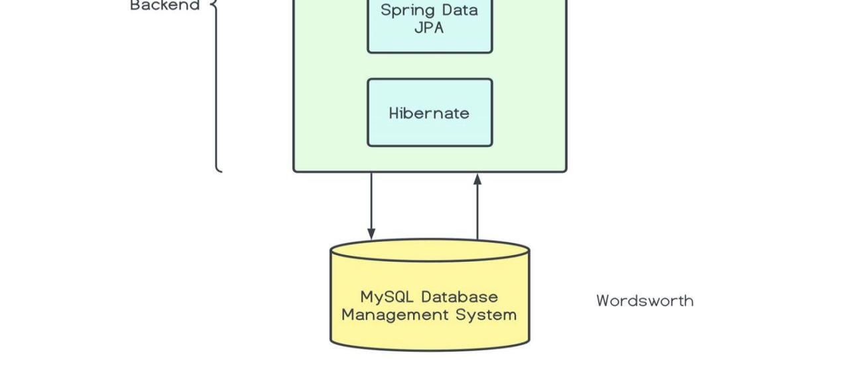

4.7. ER DIAGRAM

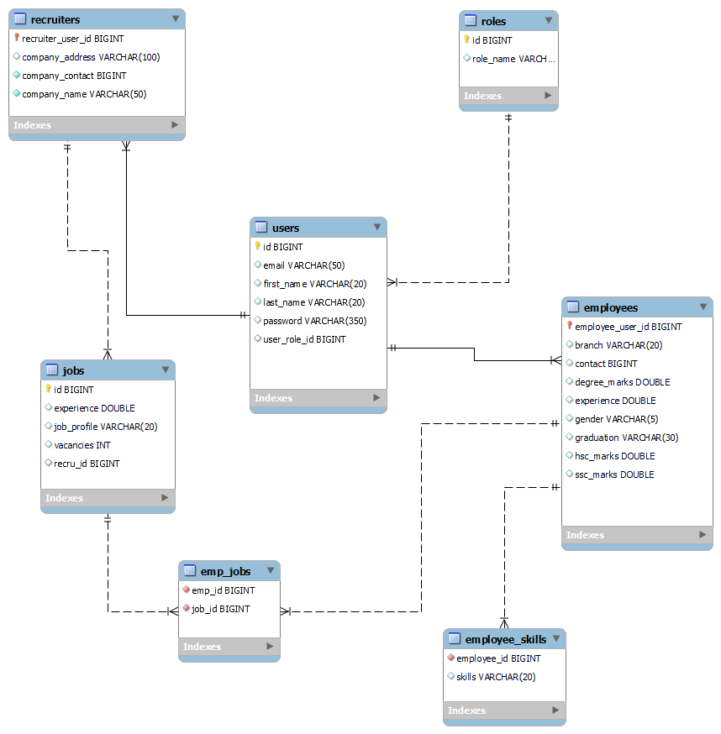

# 5. PROJECT SCREENSHOTS

5.1. Employee

Login Form

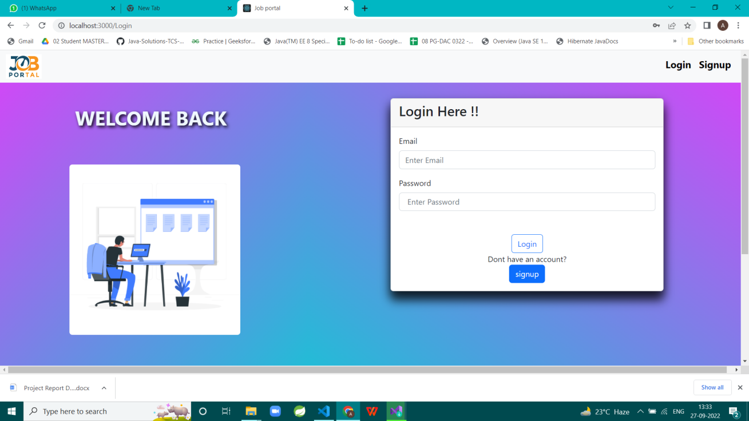

Home Page



Sign-up Page



Employee Dashboard Page



Employee Setup Page



Resume Page



Employee Update Page



Search Job Page



Update Your Info



5.2. Recruiter

Recruiter Home

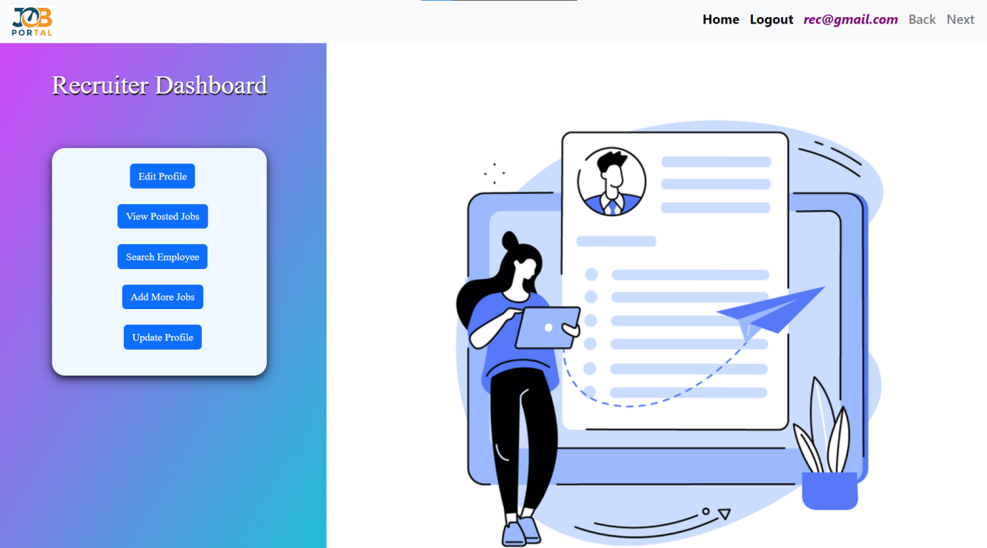

Recruiter Edit Profile

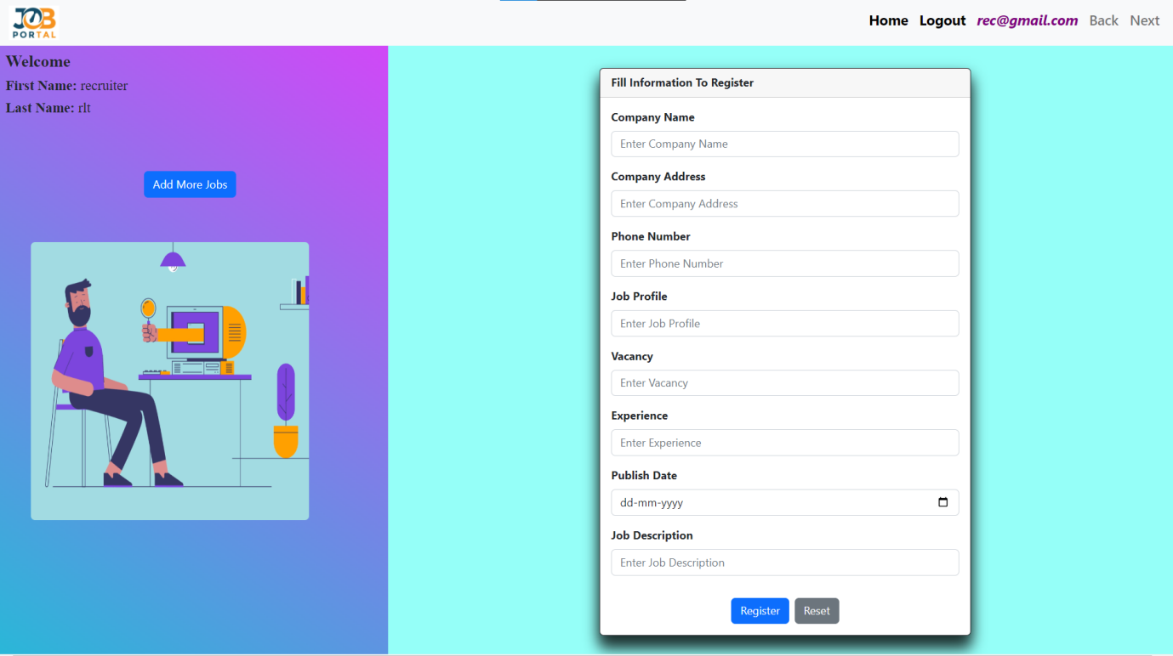

Recruiter View Posted Jobs

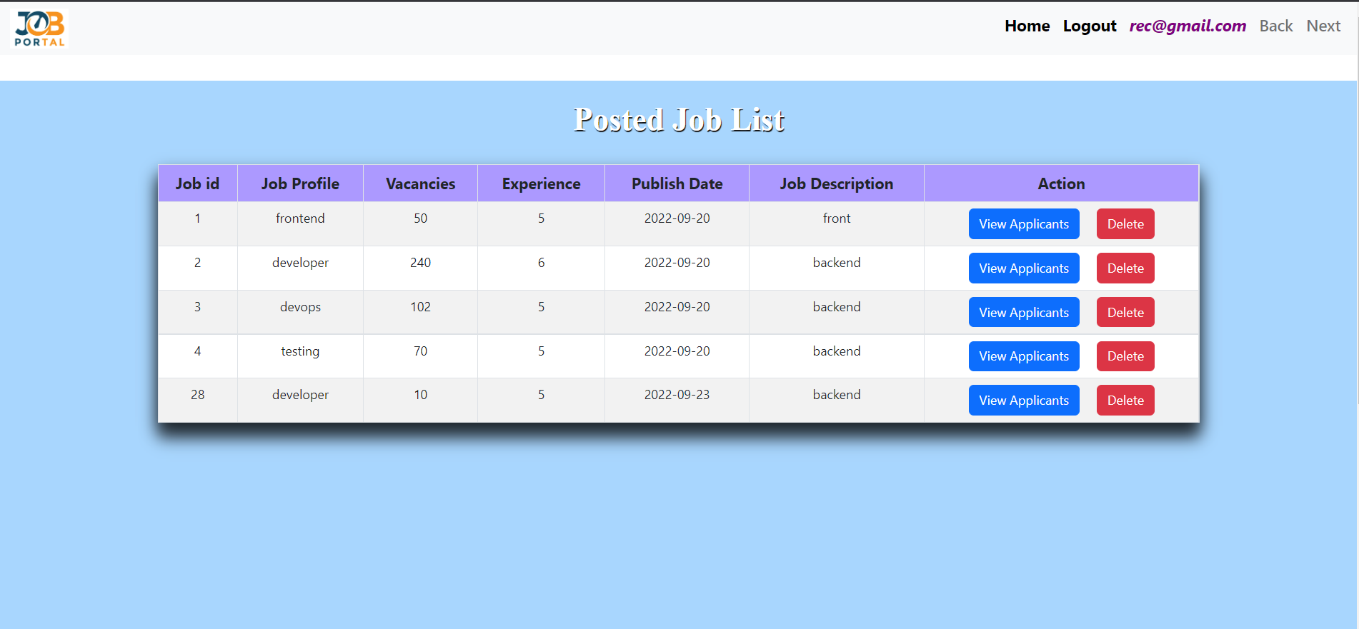

Recruiter View Applicant

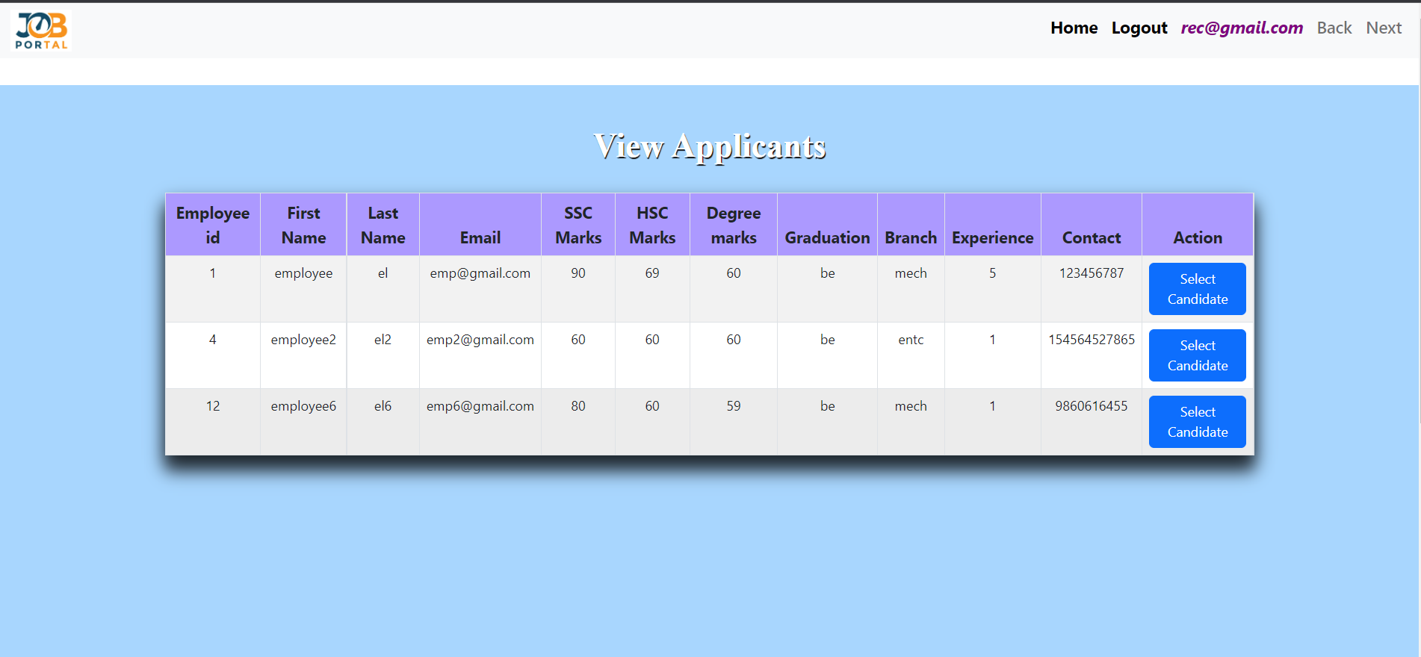

Recruiter Select Candidate

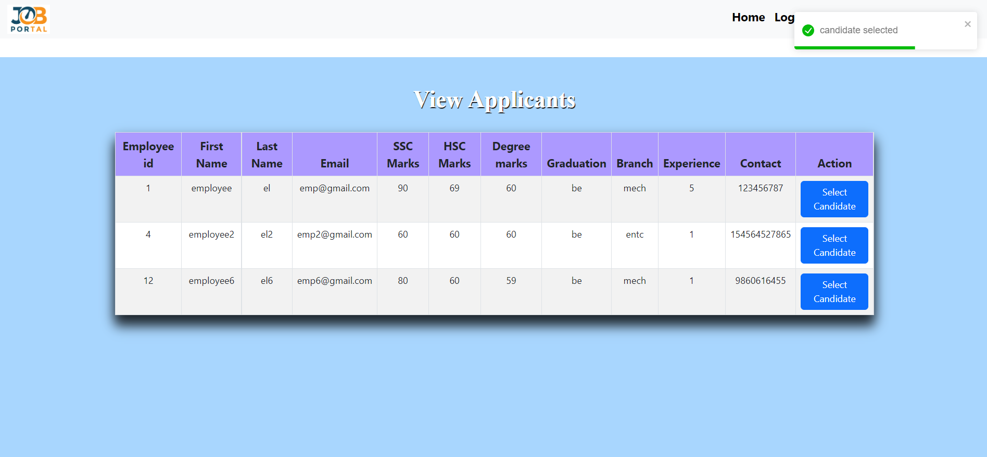

Recruiter Search Candidate

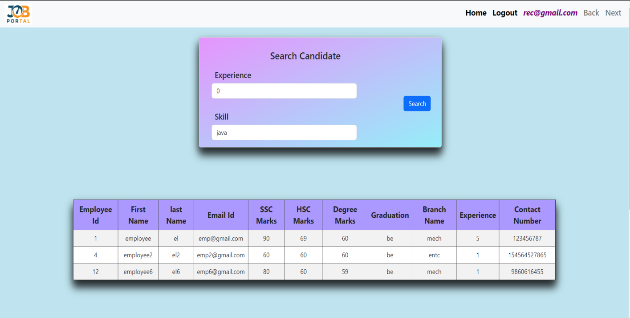

Recruiter Add Jobs

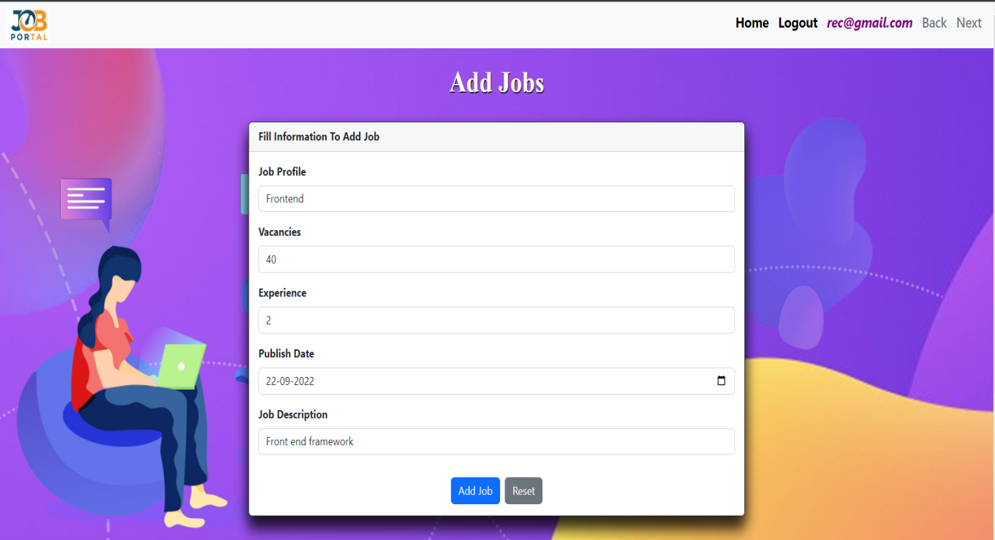

Recruiter Update Profile

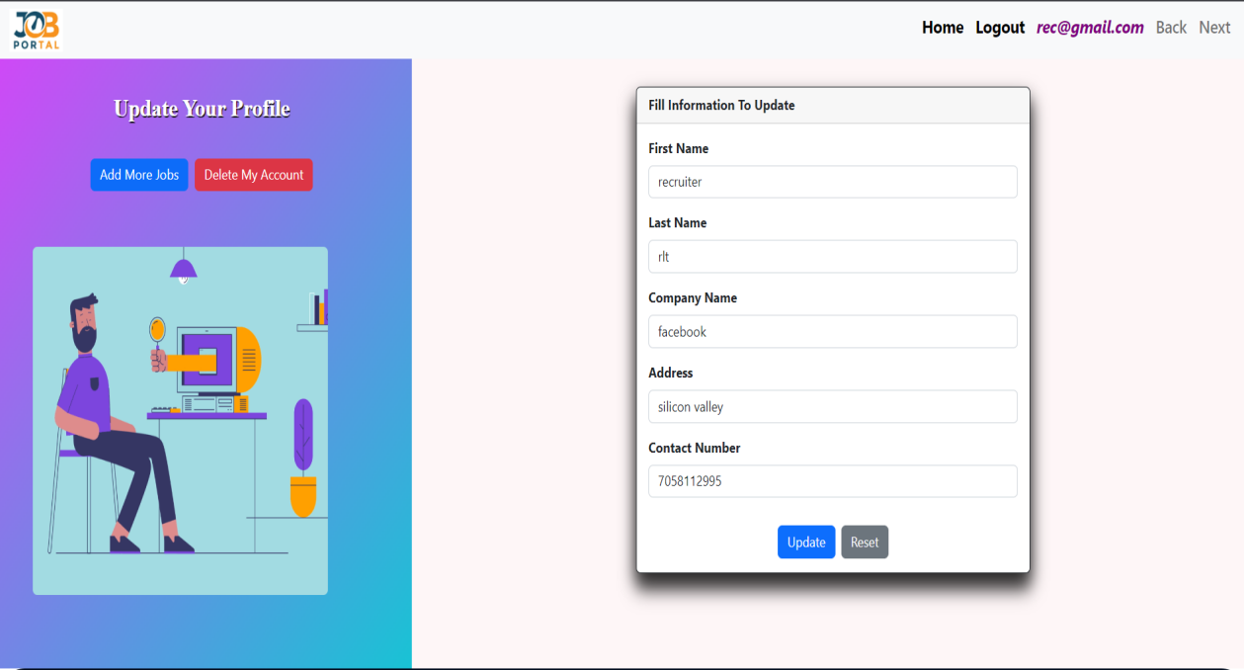

Admin Home

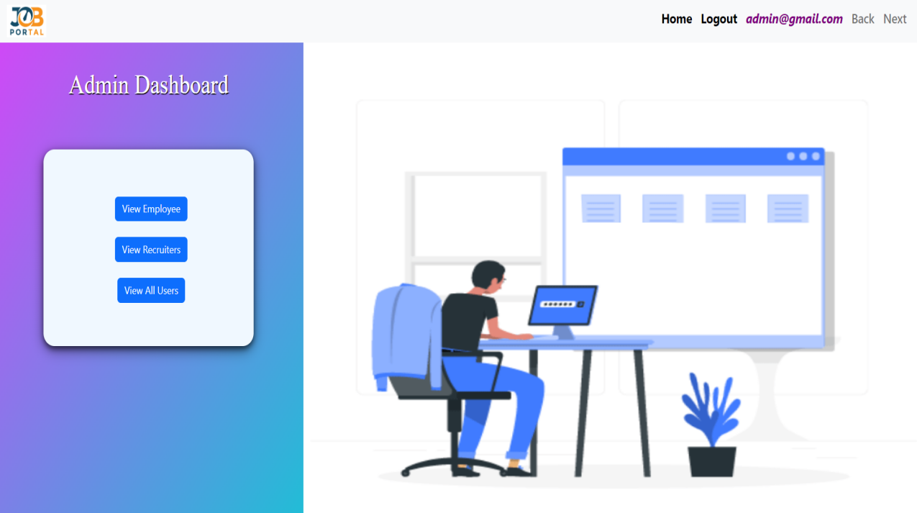

Admin View Employee

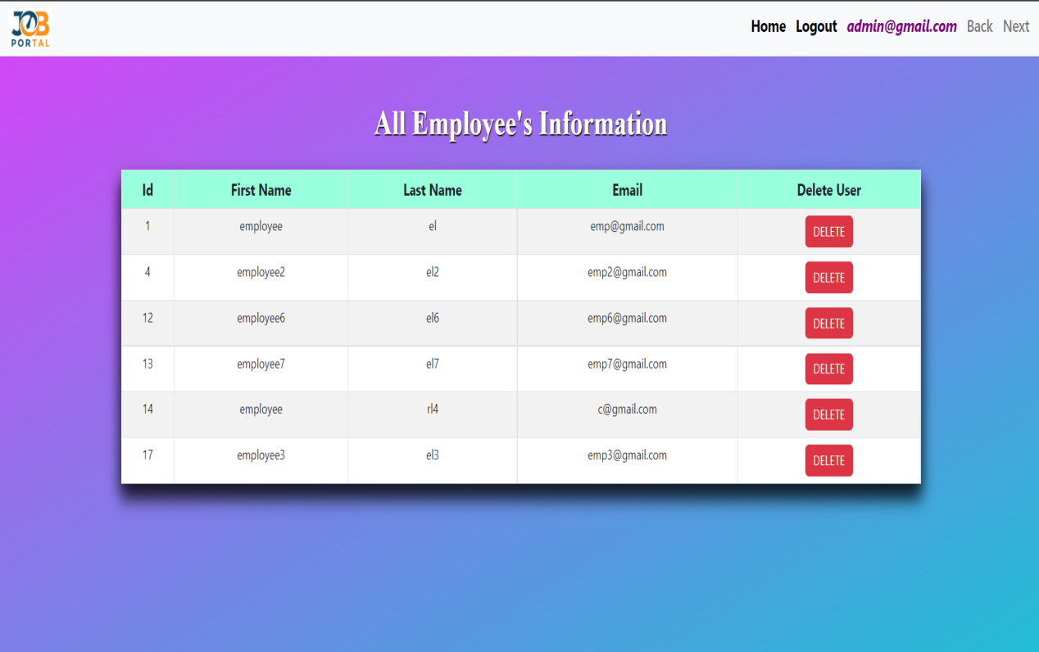

Admin View Recruiters

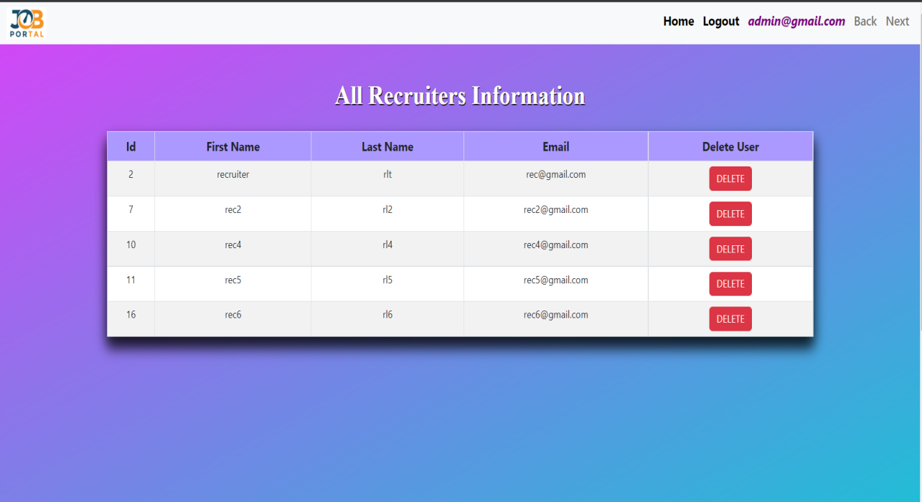

Admin View All Users

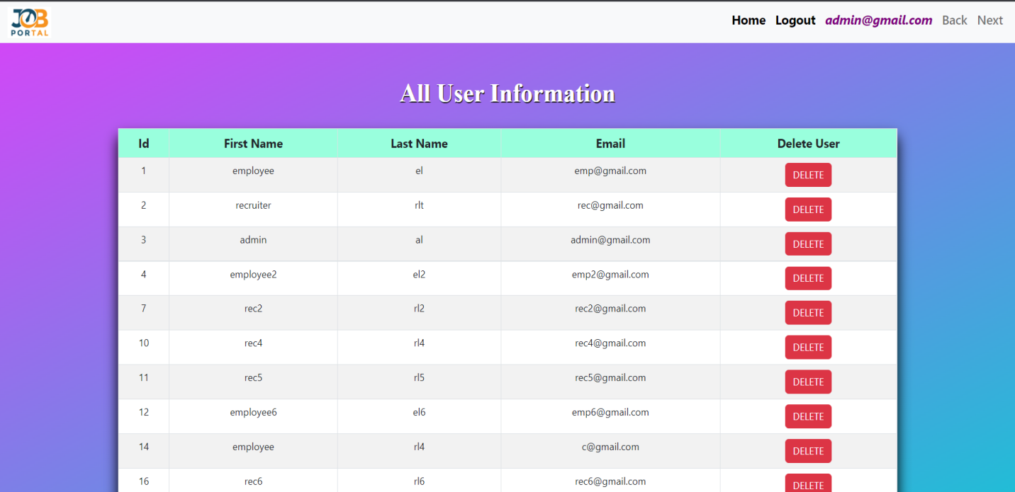

# 6. TESTING

One of the main purposes of testing is to validate and verify that the system works as intended. No program or system design is perfect. However, if we implement the system without proper testing, then it may cause problems and lead to a bad user experience.

Testing and checking outcomes of each test gives us the best chance to detect and correct errors before the system is implemented in a production environment.

In the course of our project, we made an effort to manually test each component. In all cases, we obtained the desired results as demonstrated below.

## A. Employee FEATURES TEST

|  |  |  |  |
| --- | --- | --- | --- |
| # | Description | Outcome | Result |
| 1. | Register as Employee | New employee details saved in the database. | Passed |
| 2. | Login as Employee | Fetched authenticated user details saved in database. | Passed |
| 3. | Browse Jobs | Fetched list of all jobs from the database. | Passed |
| 4. | Search Jobs by Profile | The Job with matching Profile was fetched from the database. | Passed |
| 5. | Search Jobs by Experience | The Jobs matching the filter criteria were fetched from the database. | Passed |
| 6. | Apply For Job | Successfully applied mail came and database changed accordingly. | Passed |
| 7. | Delete Account | All the details associated with employee account were removed from the database. | Passed |
| 8. | Logout | The session was cleared. | Passed |

## B. Recruiter FEATURES TEST

|  |  |  |  |
| --- | --- | --- | --- |
| # | Description | Outcome | Result |
| 1. | Register as recruiter | New recruiter details saved in the database. | Passed |
| 2. | Login as recruiter | Fetched authenticated user details saved in database. | Passed |
| 3. | Browse own Jobs | Fetched list of all jobs from the database which are posted by him. | Passed |
| 4. | See who have applied | Get list of employees who have applied to that job with resume and all details | Passed |
| 5. | Delete Job | Successfully removed job from database and connection with other tables. | Passed |
| 7. | Delete Account | All the details associated with recruiter account were removed from the database. | Passed |
| 8. | Logout | The session was cleared. | Passed |

## C. ADMIN FEATURES TEST

|  |  |  |  |
| --- | --- | --- | --- |
| # | Description | Outcome | Result |
| 1. | Sign in as Admin | Fetched authenticated user details saved in database. | Passed |
| 2. | Fetch all users | Got details of all users. | Passed |
| 3. | Delete employee | The Employee details along with all their related details were deleted from database. | Passed |
| 4. | Delete recruiter | The Recruiter details along with all their related details were deleted from database. | Passed |
| 5. | Logout | The session was cleared. | Passed |

# 7,8. Conclusion & Future work

“It has been a great pleasure for us to work on this exciting and challenging project. This project proved good for us as it provided practical knowledge of not only programming in spring and react web based application and no some extent Windows Application and MySQL, but also about all handling procedure related with online job portal. It also provides knowledge about the latest technology used in developing web enabled application and client server technology that will be great demand in future. This will provide better opportunities and guidance in future in developing projects independently

# 9. REFERENCES

Following is the list of websites we referred during the course of our project:

1. https://getbootstrap.com/docs/5.1/getting-started/introduction/
2. https://reactjs.org/docs/getting-started.html
3. https://www.baeldung.com/
4. https://www.w3schools.com/
5. https://docs.spring.io/springdata/jpa/docs/current/reference/html/#reference
6. https://javaee.github.io/javaee-spec/javadocs/
7. https://javadoc.io/doc/org.springframework.data/spring-datajpa/latest/index.html
8. https://www.naukri.com/account/register/basicdetails